Womens’ weekend at Bosei:
Training body and soul
10th & 11th May

JUST for women…
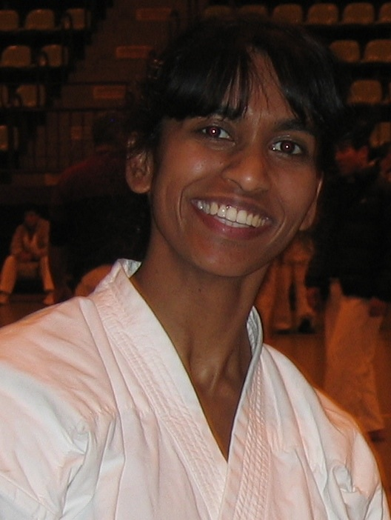
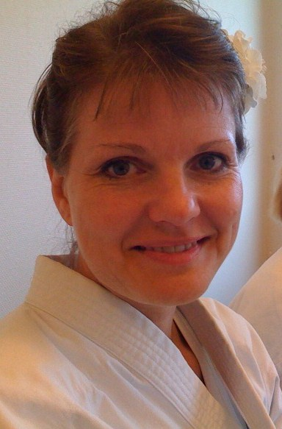
It is, once again time for the karate seminar, Just for Women. After the last seminars’ huge success, the time has come, to train, sweat and be pampered, at Bosei sports highschool in Denmark.

In a ”man’s world,” of which karate is primarily thought of, it is wonderful and refreshing, just to be women together. Even though the training is the same, there will always be a difference, depending on whether the instructor is a man or a woman, and even more so, if the recipients are men and women, or just women.

The feedback from the last time was, that it was a fantastic experience, which ought to become a yearly event. The training will be led by Sensei Reena Prasad, who is one of IOGKF’s most talented women and insightful instructor. Reena is originally from New Zealand, but now lives in England. Joining Reena are, Sensei Daniella Jørgensen and Sensei Kayle Larsen, who are two of Denmarks’ most talented female instructors.

In addition to this unique opportunity for excellent training, there will also be the opportunity to pamper the soul – in the form of a wellness treatment…

A weekend that men will envy and women simply must not miss

Training Plan – 3 training sessions on both days, where we will take advantage of the beautiful natural surroundings and the schools unique hojo undo garden (the only one in Denmark.) There will also be early morning Sanchin training before brunch on Sunday.

Eating - There will be lunch and dinner on Saturday* and on Sunday, there will be brunch and a late cold buffet lunch.

Wellness – Pamper yourself with a facemask, foot scrub, sauna and refreshing smoothies. (After training Saturday)

Accommodation – at the school. Bring your own sleeping bag and towels**
*bring money for drinks ** Bed linnen from the school costs 100kr.

Price 1 : 650 kr. Arriving Saturday morning between 8 – 9am
Incl. Overnight stay, training and food

Price 2 : 850 kr. Arriving Friday evening (after 7pm)
Incl. Overnight stay, training and food. Plus breakfast Saturday

Registration
Last date for registration is the 26th April

Name_________________________ Club_________________________

E-mail______________________________________________________________

Grade_________________________ Age __________________________

Arrival____Lør/Søn_______ Bed linen package___Y/N__

Registration to be sent to : Kayle Larsen at: kayle@bosei.dk

Registration is binding – payment takes place, upon arrival to Bosei.

Venue address: Idrætshøjskolen Bosei, Evensølundvej 5, 4720 Præstø, Denmark
