Bay Karate Club.

Dave Robottom & Nicki Walker
29 Whiting Crescent
Napier
Dave 027 4491794
Nicki 027 4085822
Technical Training Techniques... seminar #1

Guest Instructor: Sensei Derek James

Saturday February 15th 2014
William Colenso College Gym
Morris Spence Ave, Napier
10am to 4pm
$30.00 pp
Bring a light lunch & a cold drink
Tea & coffee provided
3rd Kyu and above, 16 years minimum

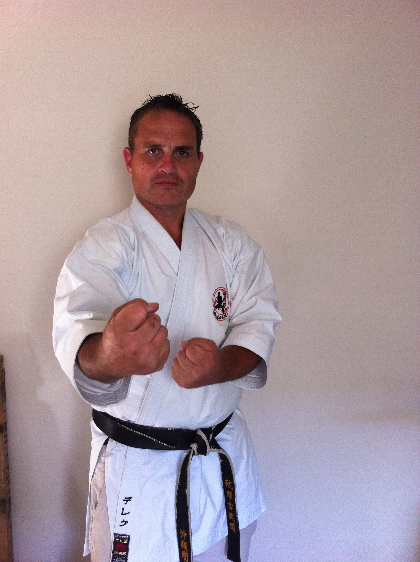

Bay Karate Club.

Sensei Derek lived, worked & trained in Okinawa 1992-2004

Uehara Karate Dojo, Okinawa Goju Ryu Bujutsu Kyokai: Shihan- 5th dan
Ryukyu Kobudo Weapons Association: Shido-iin - 4th dan
Goju Ryu Bujutsu Kyokai New Zealand: Kancho - 6th dan

The training seminar will focus on Kigu tanren (tan, chiishi, nigiri-game) tanden, kakiei, tensho. The concept of Shu-Ha-Ri.
Please bring your own, chiishi, tan & nigiri-game.
We will have some equipment to share.

We are extremely honoured to have Sensei Derek teaching at our first Technical Training Seminar. We would like to invite all members of IOGKFNZ to come along and train with us for the day. It will be a day of learning and practising senior technical techniques.
Please register your interest by email: nickiwalker66@icloud.com

